

INSTRUCTIONS FOR USE
ZOI
ILIOS 7000 SERIES SURGICAL LIGHT
DOUBLE DOME STANDARD

ZOI-SL-IL-7200

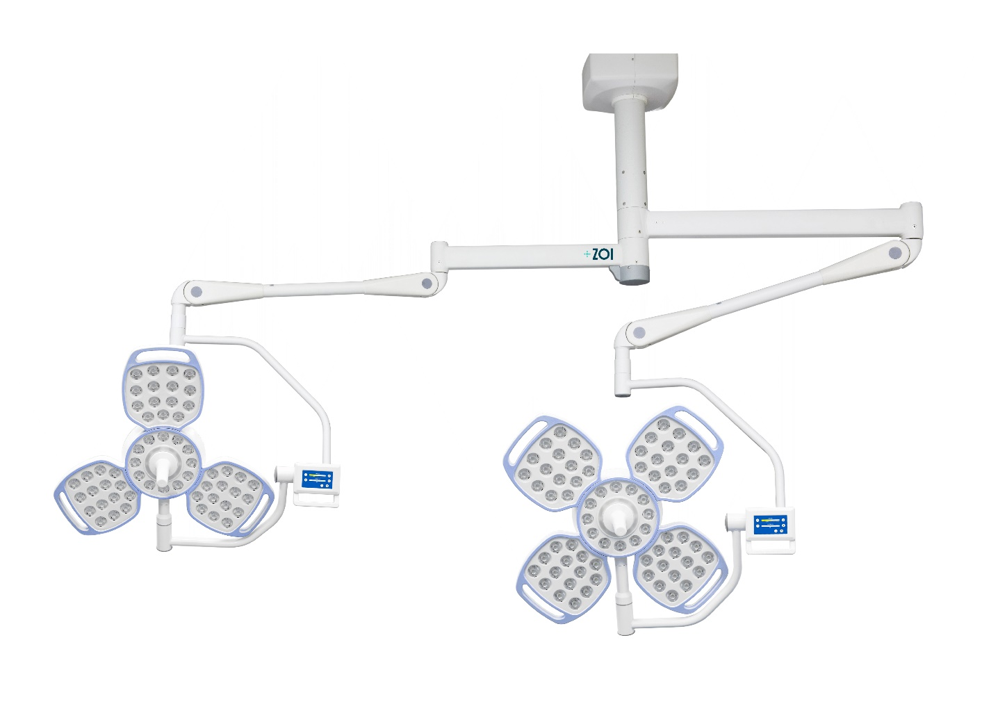
DISTRIBUTOR :
THIS MANUAL SHOULD BE PROVIDED TO USERS OF THE PRODUCT.

USER :
READ THE INSTRUCTIONS FOR USE BEFORE USING THE PRODUCT. SAVE YOUR USE MANUAL FOR FUTURE REFERENCE.

FOREWORD
Dear Customer,
Thank you for your willingness to purchase the ZOI Ilios 7000 Series Surgical Light Double Dome Standard. This instruction manual sets out all the information about this type for you, including design, dimensions, instructions for use, care, packaging, transportation and storage. You are strongly advised to read this manual carefully before using this product.
Errors in the printing process cannot be avoided. We apologize if there are such errors due to reasons beyond our control. We reserve the right to make modifications without prior notice, and you may find some content that is different from actual product use.
In this case, PT Cahaya Hasil Cemerlang Multi Manufaktur will be mentioned as the producer in the next writing and PT ZOI Medisains Indonesia will be mentioned as the distributor in the next writing.
Please contact us if you find any errors in these instructions for use.
Before using the product, you are advised to:
- Make sure that all parts and documentation are packaged before installation. Please contact the distributor or manufacturer if anything is left behind.
- Before use, please read the attached documents and data carefully and familiarize yourself with the tool. The manual should be retained for future use. The manufacturer and distributor are not responsible for damage to the instrument due to misuse, nor any potential damage thereafter.
- This product should only be used and/or supervised by Professional Health Personnel.

GENERAL INFORMATION
Table 1 General Information
Product Name | ZOI Ilios 7000 Series Surgical Light Double Dome Standard
Product Brand | ZOI
Product Type | ZOI-SL-IL-7200
Manufacturer | PT Cahaya Hasil Cemerlang Multi Manufaktur  Kawasan Industri Delta Silicon 3, Jl Pinang Blok F23 - 15B, Cikarang, Jawa Barat 17530 - Indonesia
Distributor | PT ZOI Medisains Indonesia  Jakarta Barat, DKI Jakarta 11730 - Indonesia
Edition | First, 2023
Revision | 0.0

DECLARATION OF CONFORMITY
The manufacturer states that this product complies with the following standards:
- SNI IEC 60601-1:2014 concerning Electromedical Equipment - Part 1: General Requirements for Basic Safety and Essential Performance (IEC 60601-1: 2005, IDT).
- ISO 14971:2019 concerning the Application of risk management to medical devices.
EXPLANATION OF MARKING
The following marking symbols are attached to the product label and its packaging,
Table 2 Symbols for marking product labels and packaging
Symbol | Explanation
 | Warning notices indicating risk of injury or damage to health
 | Read the instructions in the user manual
 | Manufacturer
 | There is no electrical contact with the user
 | Read work instructions before use
 | Keep it dry
 | Top and bottom position instructions so that the product does not tip over
 | Instructions for fragile products and handle with care
 | Keep away from sunlight
 | Do not turn the product upside down
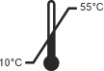 | Temperature limits
 | Hot Surface Warning
 | The body of the device must be connected to ground
 | Index Protection (Protected from solid objects > 1 mm in diameter, and not protected against liquids)
 | Alternating voltage source / AC

WARRANTY INFORMATION
This guarantee is only given to original buyers who purchase new/unused products from the designated manufacturer or distributor. This warranty is not extended by any other person or entity and is not transferable or transferable to subsequent purchasers or owners. Coverage in this warranty does not apply to subsequent sales or transfer to another person.
The manufacturer warrants the mechanical and electrical components of this product when purchased new and unused to be free from defects in materials and workmanship for a period of 24 months from the date of purchase from the manufacturer or distributor, with a copy of the bill of sale required as proof of coverage under this warranty. The manufacturer warrants that each product is free from defects in materials and workmanship as long as it is used normally during the warranty period.
The guarantee can be claimed if the damage according to our technician's inspection is caused by a manufacturer error. The guarantee covers labor costs and spare parts.
The guarantee does not apply to the following things :
- Damage caused by misuse (not following the user manual), misuse and due to natural disasters.
- This product should only be used and/or supervised by Professional Health Personnel. If the product is damaged because it is used by a user who does not comply with the provisions, then this condition is beyond the responsibility of the manufacturer and distributor.
- Storage that does not comply with instructions.
- Damage from unreasonable use.
- Items and accessories are lost.
- Do not attach proof/receipt of purchase
AFTER SALES SERVICE
When you need product support :
- For further support please contact the Distributor Hotline
Before contacting the Distributor Hotline, please prepare the following information:
- Warranty card
- Proof/receipt of purchase
- Brand/type and product serial number
- Product problems

SAFETY REQUIREMENTS
Instructions for use use the following requirements:
- Notes
Read these instructions for use carefully and save them for later use, making sure to make them accessible to other users and observing the information stated in the instructions for use.
- Attention
    - Use caution when transporting or handling equipment to avoid damage to the equipment.
    - When replacing parts, be sure to use the accessories provided by our company.
    - Portable or mobile radio frequency communications equipment will affect medical electronic equipment. When installing this equipment, be sure to ensure that the installation environment meets the requirements.
    - Do not touch component pins with ESD warning signs. If you need to touch such components, you should take effective antistatic measures, including wearing antistatic clothing and shoes, and maintaining a grounded condition during the connection process, or using antistatic gloves. Persons who may come into contact with such components should be trained in the antistatic measures mentioned above.
- Warning
- This equipment can only be used within the specified application scope, never use it for other purposes.
- This equipment can only be installed by authorized personnel of our company
- This equipment should only be operated by trained personnel.
- Please read and understand this manual before using this equipment.
- When installing this device, be sure to install an external all-phase power disconnect device (this device is not included in this device) and connect an external all-phase power disconnect device to this device.
- These lighting lamps rely on a ground protection system to achieve electric shock protection. When installing, ensure that the protective ground system in the operating room is safe and reliable.
- This equipment is suitable to work on 220VAC, 50Hz. Voltage that is too high or too low can affect the light intensity and life cycle of the LED.
- When checking or maintaining equipment, be sure to use an external all-phase power disconnect device to disconnect the lighting power first.
- There must be a main switch that can cut off electricity to the entire system. Damage to the cable insulation can cause electric shock.
- Electromagnetic waves from equipment such as nuclear magnetic resonance may cause malfunction of this product, please keep away from any equipment that may affect this product.
- Do not look directly at the light source (LED).
- When disposing of this product, please do not dispose of it carelessly. Dispose of according to local regulations and environmentally friendly methods.

INCLUDED IN SHIPPING
Table 3 List of Items in Delivery
No. | Item | Qty
1. | Instructions for use | 1 piece
2. | Guarantee card | 1 piece
3. | Certificate of Analysis (CoA) | 1 piece
4. | ZOI Ilios 7000 Series Surgical Light Double Dome Standard | 1 set
5. | Bolt and tool | 1 set

LIST OF CONTENTS
FOREWORD 1
LIST OF CONTENTS 7
1.1 PRODUCT DESCRIPTION 8
1.2 TECHNICAL SPECIFICATIONS 9
1.3 MECHANICAL SPECIFICATIONS 11
CHAPTER 2 PROCEDURES FOR INSTALLATION
AND USE OF THE PRODUCT 13
2.1 PROCEDURE FOR INSTALLATION OF THE PRODUCT 13
2.1.1. BASIC REQUIREMENTS 14
2.1.2. HOW TO INSTALL 14
2.1.3. INSTALLATION OF HANGING PIPE 16
2.1.4. ROTATING ARMS INSTALLATION 17
2.1.5. CANTILEVER INSTALLATION 17
2.1.6. INSTALLATION OF LIGHTS 19
2.1.7. STERILE HANDLE INSTALLATION 19
2.2 PROCEDURE FOR PRODUCT USE 20
2.2.1. CONNECT THE POWER SUPPLY 20
2.2.2. FUNCTION CHECK 21
2.2.3. OPERATION PANEL INSPECTION 21
2.3 EXPLANATION and HANDLING OF ERROR FUNCTIONS 22
CHAPTER 3 CLEANING AND MAINTENANCE 23
3.1 PROCEDURE FOR PRODUCT MAINTENANCE AND CLEANING 23
CHAPTER 4 CONSULTATION AND SERVICES 24
CHAPTER 1 PRODUCT INTRODUCTION

PRODUCT DESCRIPTION
Surgical Light Double Dome is applied in medical institutions to provide additional lighting in the operating room, to locally illuminate the surgical area or patient examination. Surgical Light Double Dome is a lighting lamp without automatic failure prevention function, and can also be used alone for small operations without shadowless effect. The Surgical Light Double Dome consists of arms that are arranged vertically or horizontally and can be adjusted to suit the needs during the surgical procedure. The light spots produced by several LED lamp beads gather in the center directly under the lamp head at a distance of 1 m from the lamp head, thereby forming a lighting effect that satisfies medical users.
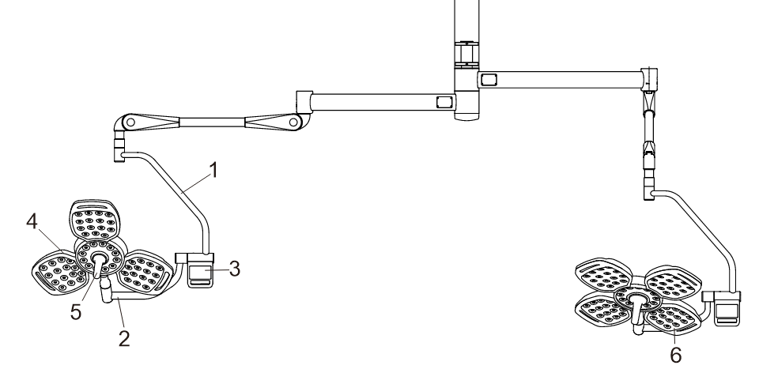

Figure 1 Product Parts

Table 4 Description of Product Components
No. | Description
1. | Swivel Curved Arm/Swivel Arm
2. | Support
3. | Control Panel
4. | 3 Petal Lamp Head
5. | Hendel Sterile
6. | 4 Petal Lamp Head

TECHNICAL SPECIFICATIONS
Table 5 Technical Specifications
Product description | ZOI Ilios 7000 Series Surgical Light Double Dome Standard
Type | ZOI-SL-IL-7200
Material | Allumunium Alloy and Stainless Steel
Voltage | 220 VAC
Frequency | 50 Hz
Power Consumption | 180 VA + 220 VA
Lamp head diameter | 740 mm (3 petals & 4 petals)
Maximum Illumination | 3 petals : 140,000 Lux  4 petals : 160,000 Lux
CRI Color Rendering Index (Ra) | ≥ 95, typical 97
Illumination Range | 3 petals : 40.000 ~ 140.000 Lux  4 petals : 40.000 ~ 160,000 Lux
Illuminated Spot Temperature Rising | ＜ 0.5℃
Color Temperature | 3.500 ~ 5000K (5 Steps Adjustment)
Light Spot Diameter Adjustment Range | 18-25cm
Lighting Depth（20%） | 3 petals : 100 cm ± 5%  4 petals : 120 cm ± 5%
Radioactivity Ee/Ec | ≤ 4.5 MW/m² lux
Max Radioactivity (Ee) | 3 petals : ＜500w/m²  4 petals : ＜600w/m²
Lamp Lifetime | > 60,000 Hours
Working Temperature | 10℃ - 30℃
Humidity | <70% Rh
Atmospheric Pressure | 860 hPa – 1060 hPa
Increased Lighting Temperature | <0.5℃
Increased Head Temperature | <1℃

MECHANICAL SPECIFICATIONS
Table 6 Technical Mechanical Specifications
Rotating Angle Of Upper Rotating Arm Around Ceiling Fixation Base | 360°
Spring Arm Max Rotation Angle In Horizontal Direction | 360°
Spring Arm Max Downwards Tilting Angle | 45°
Spring Arm Max Upwards Tilting Angle | 45°
Lamp Head Horizontal Rotational Angle Around The Spring Arm Connection Joint | 360°
Horizontal Bending Arm Leftward Rotational Angle Around The Vertical Bending Arm | 135°
Lamp Head Leftward Rotational Angle Around The Horizontal Bending Arm | 135°
Horizontal Bending Arm Rightward Rotational Angle Around The Vertical Bending Arm | 135°

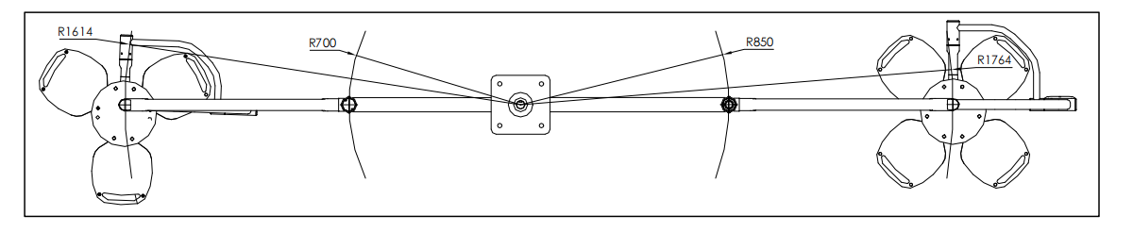
Figure 2 Horizontal Surgical Light Working Range
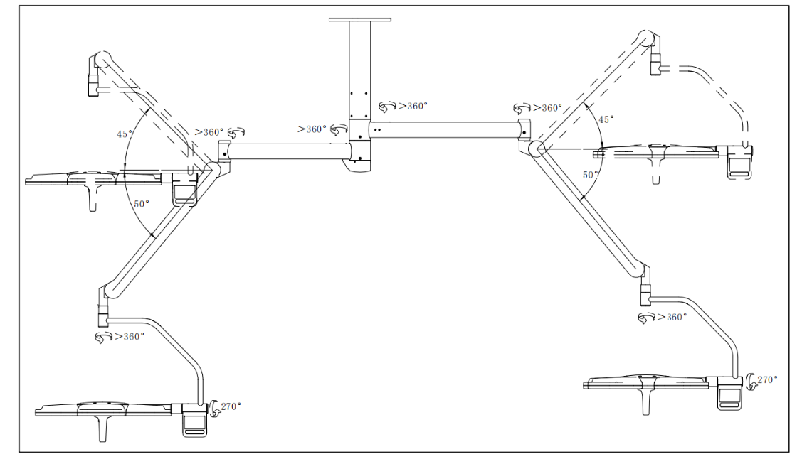
Figure 3 Vertical Surgical Light Working Range
.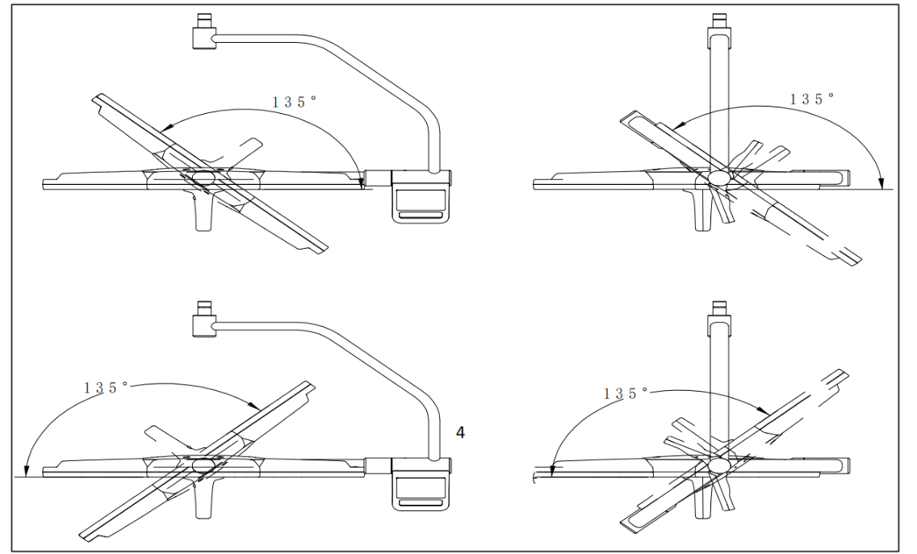
Figure 4 Lamp Head Rotating Arm

CHAPTER 2 PROCEDURES FOR INSTALLATION AND USE OF THE PRODUCT

PROCEDURE FOR INSTALLATION OF THE PRODUCT
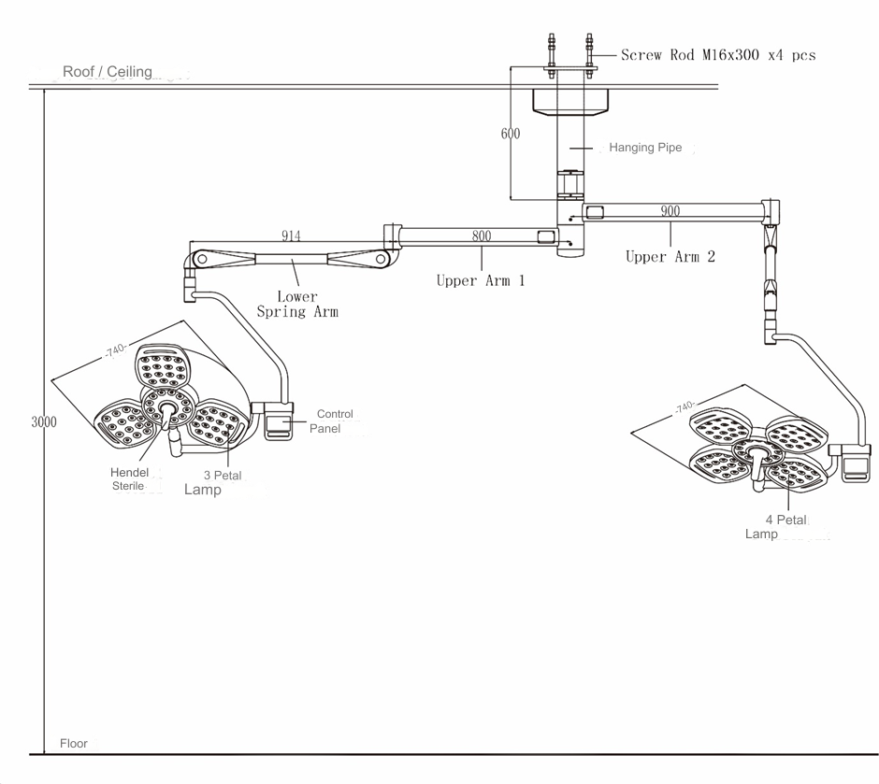
Figure 5 Product Structure

BASIC REQUIREMENTS
Please determine in advance the product model to be installed. and ensure the roof structure meets the minimum requirements for Bearing Load above 1000 N with a Torque of 950 Nm as a reference for pre-installation. Based on overall safety considerations, please adjust the structural safety factors appropriately to meet actual needs.

HOW TO INSTALL
Embed four M18 screws or expansion bolts in the building structure, and make the tail end of the bolt column protrude about 8 ~ 10cm from the ceiling surface (as shown in Figure 6). and make sure these screws are spread over a square area with side lengths of 20~30cm.
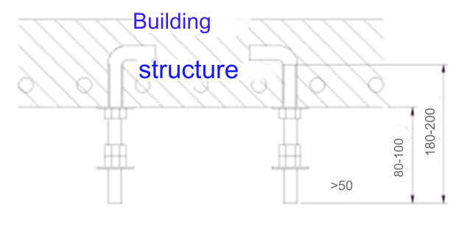
Figure 6 Building Structure

Then make a mounting frame according to the position of the screw or expansion bolt and leave the position of the product mounting hole on the mounting frame (see Figure 7).
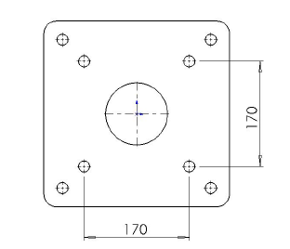
Figure 7 Flange

The installation is completed as shown in Figure 8.
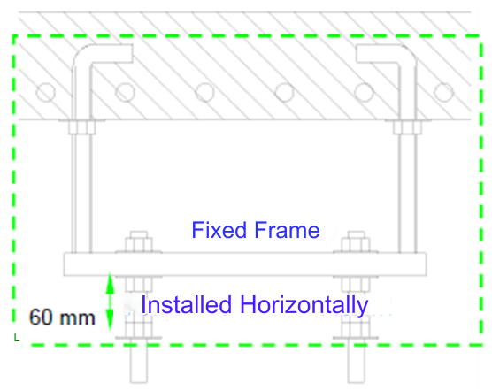
Figure 8 Flange with Base

INSTALLATION OF HANGING PIPE
Select different hanging pipe specifications to ensure the height of the lower end of the hanging pipe from the ground is 2500 mm. Use M16 screw nuts, M16 screw rods, washers and spring washers to install the suspension pipe as shown in Figure 9.
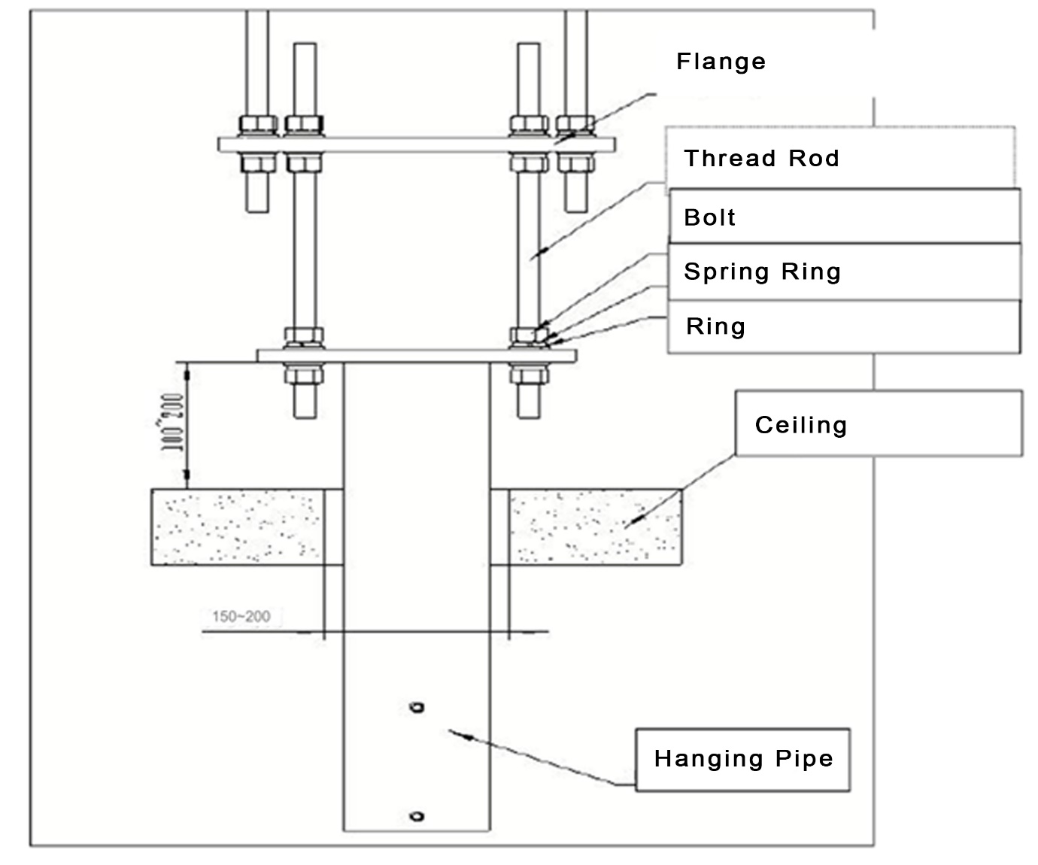
Figure 9 Hanging Pipe Installation Structure

ROTATING ARMS INSTALLATION
Please remove the 8 pieces of pre-installed M6x16 countersunk screws from the swivel arm first, then arrange the swivel arm cable well. Make the arranged cable enter through the bottom end of the suspension pipe and exit from the flange end of the suspension pipe. Install the swivel arm into the suspension pipe according to Figure 10, and use 8 M6x16 countersunk screws removed from the swivel arm to securely lock the suspension pipe and swivel arm.
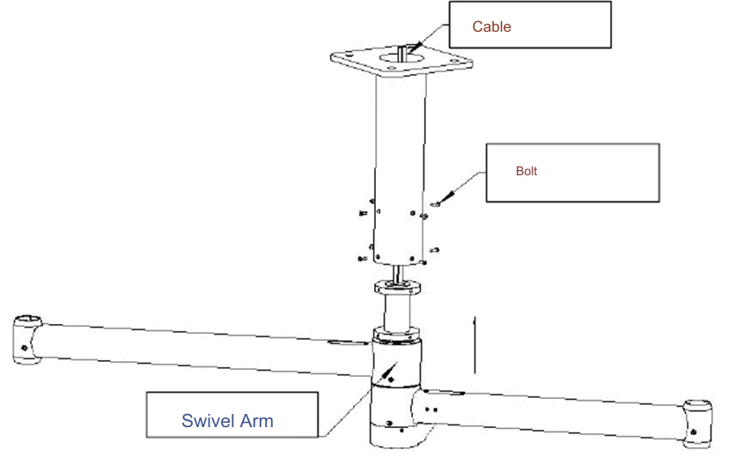
Figure 10 Swivel Arm Mounting Structure

CANTILEVER INSTALLATION
The method of installing both types of cantilever on the rotating arm is the same. As shown in Figure 11.
- Open the sleeve cover at the end of the swivel arm, pull out the conductive plug, and unscrew the cantilever reducer counterclockwise so that the copper screw head does not block the installation of the cantilever.
- Take out the cantilever, then remove the retaining ring from the cantilever.
- Insert the cantilever up from the bottom end of the swivel arm as shown in Figure 11.
- Use spring-loaded pliers to install the cantilever retaining ring into the cantilever position.
- Insert the conductive plug of the swivel arm into the cantilever.
- Lock the swivel arm cover to the swivel arm with the swivel arm cover fixing screw.
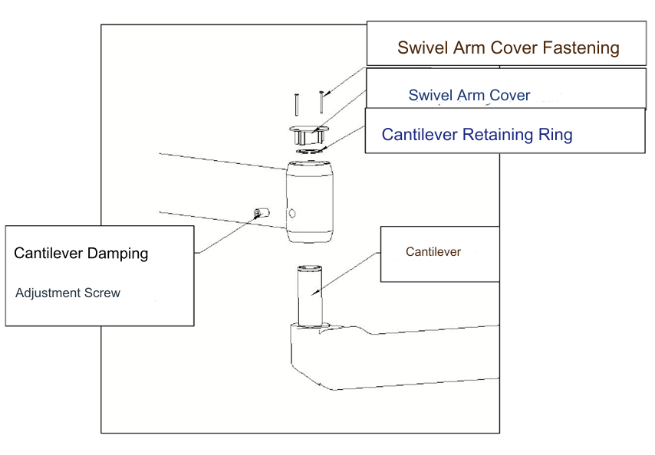
Figure 11 Cantilever Mounting Structure

INSTALLATION OF LIGHTS
How to install lights with a cantilever can be seen in Figure 12:
- Use a cross-type screwdriver to remove the fixing screw from the cantilever end.
- Push the sliding cantilever up.
- Remove the stuck part of the cantilever.
- Install the lamp head on the cantilever according to Figure 12.
- Insert the stuck part of the cantilever into its release position in step 3.
- Push the top cantilever slide down.
- Lock the cantilever fixing screw.

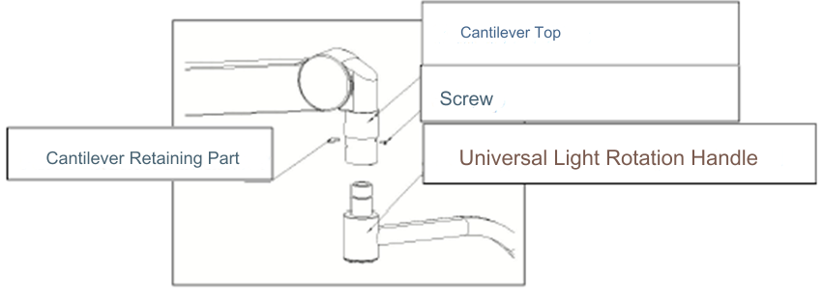
Figure 12 Light Installation Structure
Warning: Make sure that the stuck part of the cantilever is installed in place. Otherwise, there is a danger of the lamp body falling.

STERILE HANDLE INSTALLATION
Installing the steering handle on the lamp can follow the steps below,
- Please follow figure 13 below, insert the sterile handle's outer part along the direction of the inner part of the handle, push the outer part of the handle forward. Rotate the outer part of the handle from left to right until you hear a "click" sound.
- Pull the outside of the sterile handle in the opposite direction to installation to ensure secure installation.
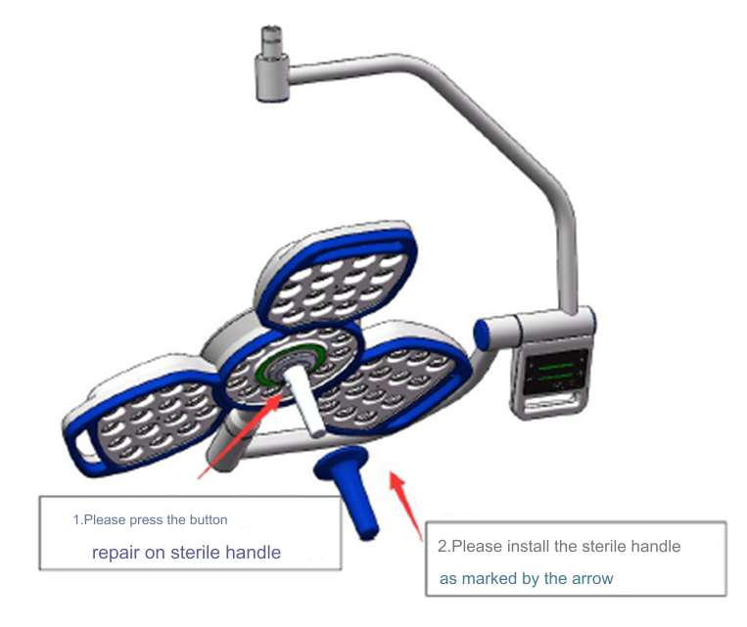
Figure 13 Sterile Handle Installation Structure

PROCEDURE FOR PRODUCT USE

CONNECT THE POWER SUPPLY
Before turning on the power, please turn off the power. Each lamp head of this product uses an independent power supply switch. Please confirm whether sufficient power output terminals are reserved. And each power output is connected in parallel.
- Connect 220V 50HZ power to replace the “L” “N” power supply and ground.
- Connect the brown wire from the cantilever to the power “+” side terminal of the switch.
- Connect the blue wire from the cantilever to the power “-” side terminal of the switch.
- Connect the yellow and green wires from the cantilever to the ground terminal of the start side of the power supply.

FUNCTION CHECK
A functional check must include the following functions:
- Whether there is obvious damage to the lamp holder and lamp arm, whether all the joints can rotate flexibly, and whether the screws are loose.
- Is the indoor power supply normal.
- Whether the indoor temperature and humidity environment meet the requirements.
- Is the surgical lighting functioning normally.
- Is the surgical lighting system experiencing interference.
- Whether the control panel and buttons are functioning normally.

OPERATION PANEL INSPECTION
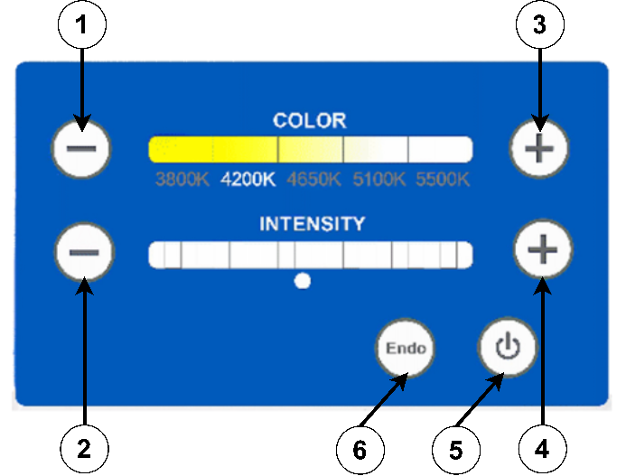
Figure 14 Operation Panel
The panel function check must comply with the following settings :
- Small-operation light point adjustment.
- Small-surgical lamp illumination adjustment
- Major-Surgical Lighting Spot Adjustment.
- Major Surgical Lighting Illumination Adjustments
- Surgical light on/off.
- Endo Mode

EXPLANATION and HANDLING OF ERROR FUNCTIONS
To handle errors and find out warnings that occur on the product. It can be seen in the following table:
Table 7 List of Error Messages
No. | Problem | Correct
1. | Rotating Curved Arm/Swivel Arm Cannot Be Positioned | Use a wrench on the angle of the arm and adjust it for damping between the rotating arms
2. | Cantilever Cannot Be Positioned | Use a wrench on the corner of the arm and adjust it to dampen the cantilever
3. | Lamp Holder Cannot Be Positioned | Use a wrench on the corner of the arm and adjust it to dampen the elbow mount
4. | Lamp Holder Cannot Supply Power | Check the wiring paths connected to the lights
5. | Cannot Turn On Surgical Light | Check the wiring lines connected to the lights, check the condition of the lights according to normal conditions
6. | Cannot Adjust Surgical Light Spot Size | Contact the Distributor Call Center for further assistance
7. | Cannot Set Lighting | Contact the Distributor Call Center for further assistance

CHAPTER 3 CLEANING AND MAINTENANCE

PROCEDURE FOR PRODUCT MAINTENANCE AND CLEANING
The product must be cleaned from time to time. To protect the product from damage, please pay attention to the following :
- Lamp Head Surface Treatment
  - Wipe away dust with a disposable rag.
  - Wipe the surface with an appropriate cleaner based on the device material and type of contamination, drying afterwards.
  - When cleaning the refractive panel under the lamp holder, pay attention: please clean from the inside (middle) to the outside. Do not use circular wiping movements or wipe back and forth to avoid scratching the glass surface.
  - After each use, the bias panel under the lamp holder needs to be cleaned. When you don't use your device, make sure you clean it at least once a week.
  - The surgical lamp surface cleaning cloth should not be soaked with too much cleaning fluid, so that the liquid does not penetrate and cause a short circuit in the surgical lamp.
- Sterile Handle Maintenance
  - Tighten the lamp holder with one hand.
  - Hold the sterile handle with the other hand & press down on the bead, then pull out the handle in the direction of the arrow.
  - Wipe the sterile handle with a clean cloth or disinfectant cloth, in preparation for pressurized steam sterilization.

If you plan not to use the product for a long period of time, we recommend storing and arranging the product in a standard position.

CHAPTER 4 CONSULTATION AND SERVICES
Thank you for your trust in using PT Cahaya Hasil Cemerlang Multi Manufaktur products. As a form of concern, we provide product consultation and product repair services.
If you have any questions you can contact us directly for service, please contact:

Distributor :
PT ZOI Medisains Indonesia
Jakarta Barat, DKI Jakarta 11730 - Indonesia

Manufacture :
PT Cahaya Hasil Cemerlang Multi Manufaktur
Kawasan Industri Delta Silicon 3, Jl Pinang Blok F23 - 15B, Cikarang, Jawa Barat 17530 – Indonesia

